Aim: Creation of Cursor
Outcome: PL/SQL block using Cursor
1.Use Emp (system table) for following:
- Display id and name of employee who are working as Salesman. (using %Type)

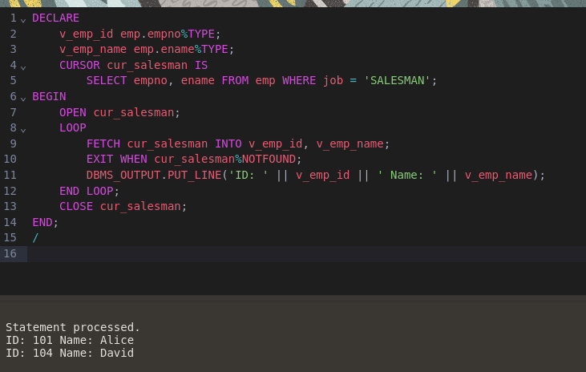

- Display all the information of employee belong to dept no 10 (using %RowType)

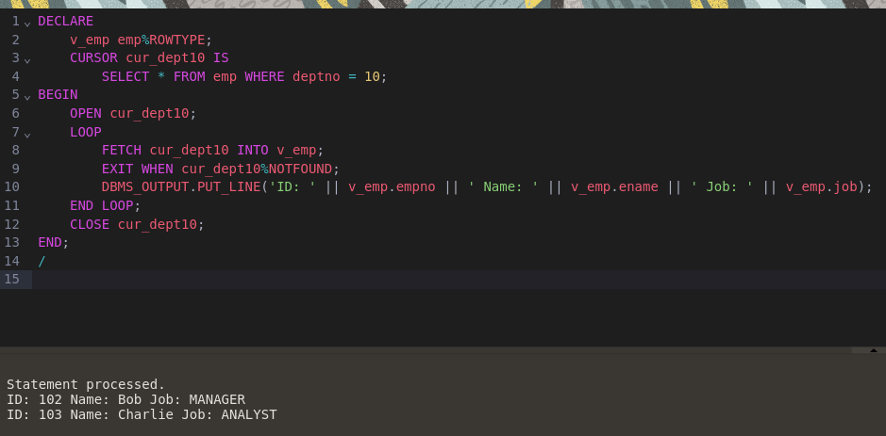

- Display name,dept no,salary of first highest paid employee

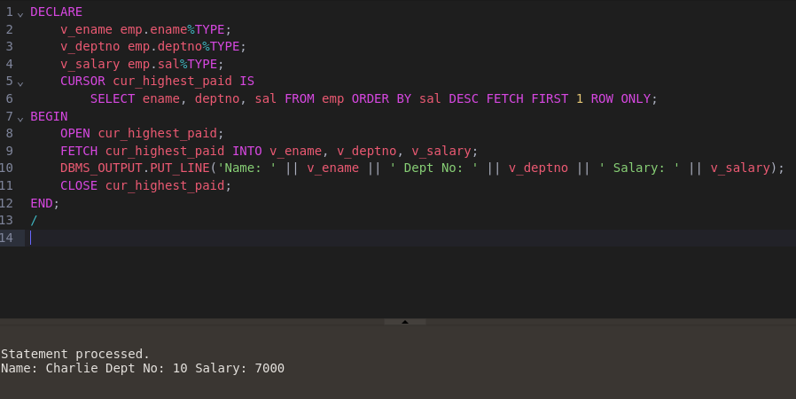

- Display the employee details along with salary (Between range : A to B)

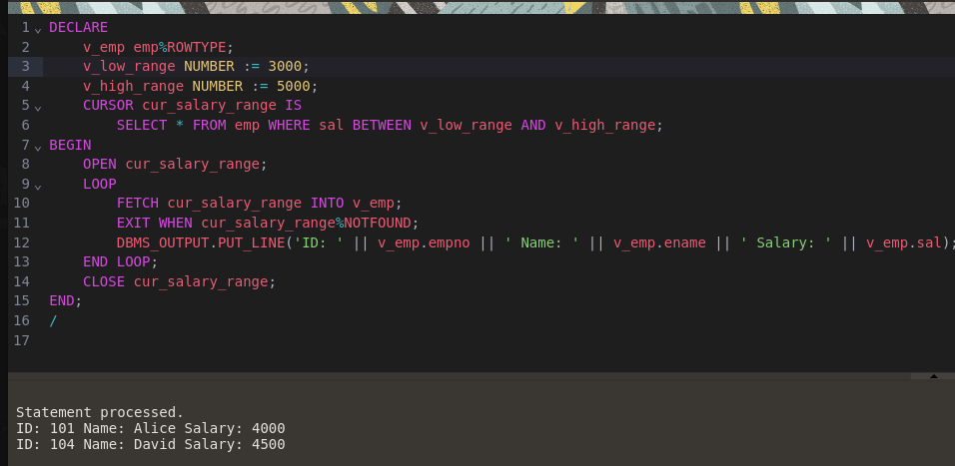

- Display the employee working as a Manager or Analyst.

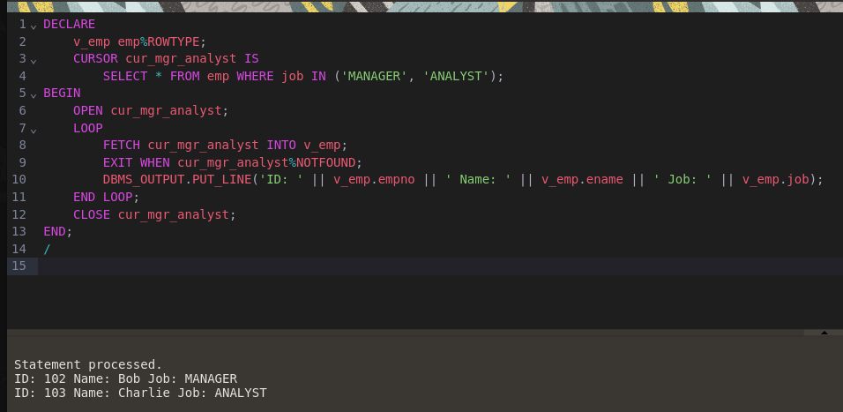

2.Employee (id,name,TA , DA, HRA,Gross,Bonus)
Calculate Gross salary and bonus (10% of salary) and insert into table (%Type OR %RowType)

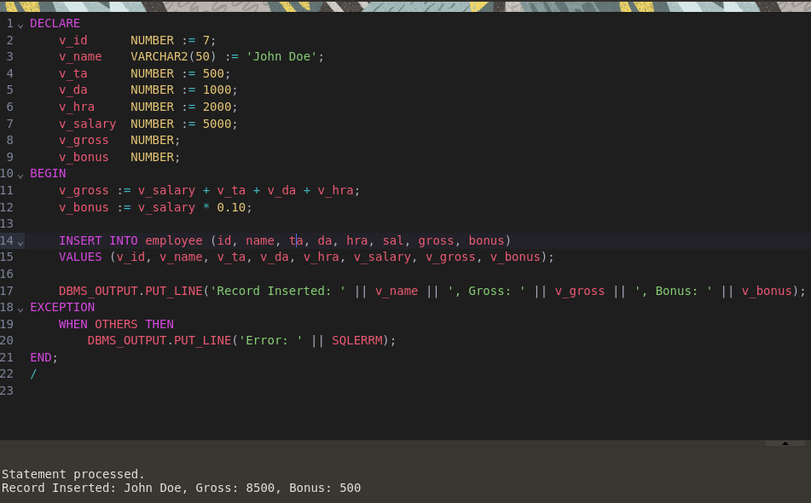

3. Write an anonymous PL/SQL block that…
  - Defines a cursor that points to a record set that contains the sailors’ names, reservation date and boat id where the boat color is red
  - Opens the cursor
  - Uses a simple loop to fetch each record in the active set
  - Displays each last name, reservation date and boat id for each record to the output screen
  - Schema
Sailor (sid, sname, rating, age)
Boat (bid, bname, color)
Reservation(sid, bid, day)

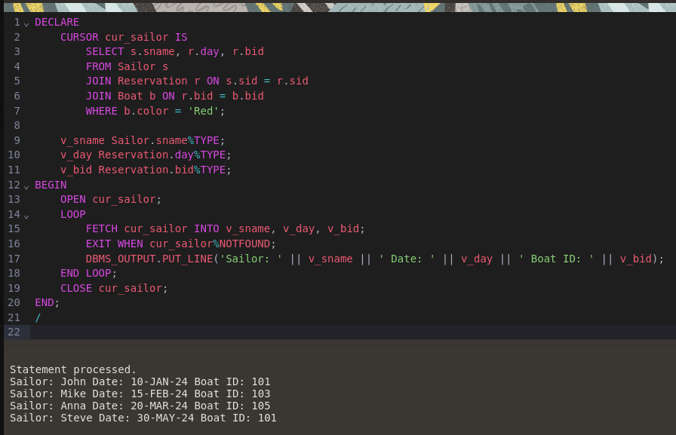

4. Try following attributes for SQL implicit Cursor:
- SQL%FOUND

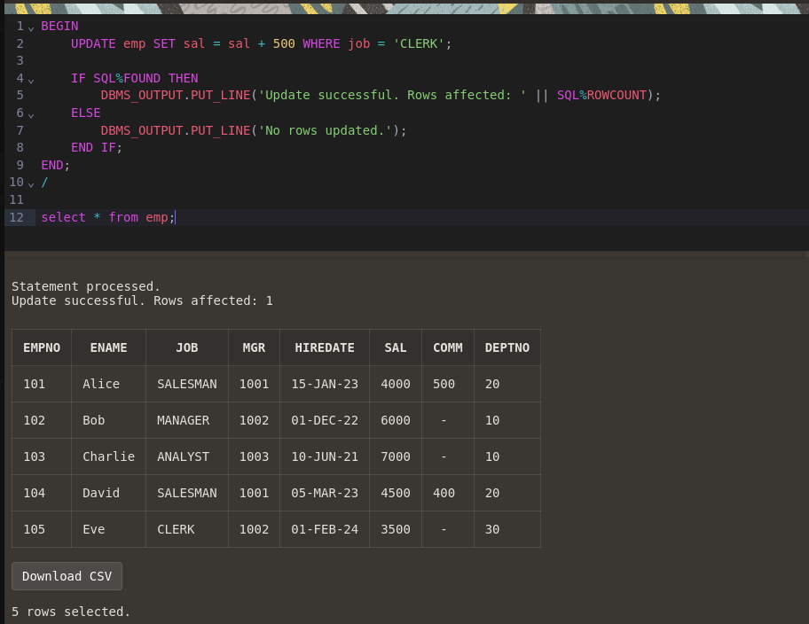

- SQL%NOTFOUND’

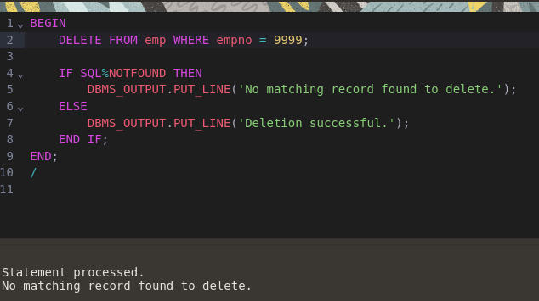

- SQL%ROWCOUNT

